**Analysis of Manual Manufacturing Processes Using Motion Sensing Technologies**

Wenchang Han, Xiaoqian Liu, Jack H. Radcliffe, Maryam Ghariban, Jane Wei, Kevin C. Chung, Peter A. Beling

University of Virginia, wh3sb, xl3ma, jhr3ct, mg5yd, jw2uj, kcc3ke, pb3a@virginia.edu

***Abstract -* To evaluate motion sensing technologies capable of collecting data that supports the analysis of workers in manufacturing environments, we developed a procedure to categorize manufacturing processes and many motion sensing technologies. Processes were decomposed into: resolution of movements, amount of noise, and detection difficulty; sensors were decomposed into: sensitivity, noise-cancellation capability, and detection capability. By analyzing each sensor alternative and checking if it provided the required functionality and level of performance, we were able to select sensor combinations for different categorized processes. The collected data were used to compare the performance differences between experienced and new workers through analytical and graphical analyses. Data analyses led us to a series of sample recommendations for novice operators to reduce their learning curves. These recommendations could also improve productivity and minimize production costs and risks related to safety.Given this methodology, manufacturers would be able to generalize the procedure to the majority of manufacturing processes and new sensing technologies in order to capture experts' tacit knowledge. We also used grit blasting as a sample manufacturing environment and five motion sensors to validate our methodology. The selected sensors were able to collect data within the working environment, and with that data we output visualizations and recommendations to the novice.**

**Introduction**

Given the competitiveness of the global manufacturing industry, it is important to improve manufacturing efficiency. There are various approaches to this—one is to capture the intuition and know-how acquired by experienced human operators, a process known as "knowledge capture." It helps to uncover the factors differentiating novice and expert workers. Benefits include 1) increasing the understanding of a process which allows for further process improvement opportunities, 2) significantly reducing the learning curve for novice operators which results in a more efficient workforce and a cheaper training process, and 3) preserving operator knowledge before a large proportion of the experienced workforce enters retirement [1]. In this paper, we sought to explore the potential of motion sensing technologies to achieve knowledge capture.

We proposed a systematic way of evaluating sensors in three steps—categorizing manufacturing processes, evaluating sensors, and mapping sensors to processes. To formulaically map sensors to processes, we defined several categories that the processes fall under based on their characteristics, e.g. the need for a highly sensitive sensor. Then we evaluated sensors by defining and testing their prerequisites, functionalities, and performances. Each process category corresponds to a set of evaluated sensors with a certain level of minimum performance. Once a process is categorized, a short list of viable sensors to be used for analysis can be easily identified. After conducting data collection with the recommended and practical (due to cost and availability) sensors, various data processing methods—visualization and regression—can be applied. The results may reveal differences between novices and experts that could be the basis for training recommendations.

We used a manufacturing process known as grit blasting as an illustrative example for our methodology. It is a process with a high resolution of movements, a large amount of noise, and a medium difficulty of detection. Sensors with high sensitivity, high noise-cancellation capability, and medium target detection capability are most suitable for its knowledge capture. Sensors that could not meet the functionality and performance requirements, such as the Leap Motion, Microsoft Kinect 1, and Creative Senz3D, generally failed to provide workable data. On the other hand, the Animazoo motion capture suit IGS-180i and Microsoft Kinect 2 could output useful data for further processing. By comparing the data from novice and experts, we were able to make recommendations on how much to improve in terms of standoff distance, blasting angle, blasting sequence, and blasting speed.

This methodology significantly streamlines the process to use motion-sensing technologies for knowledge capture on different manufacturing processes. Although data processing is time consuming, the scalability of this methodology—the ability to generalize the process on new sensors and processes—enables companies to improve manufacturing efficiency with sensors widely available on the market.

**Process Categorization**

There are hundreds of thousands of manufacturing processes in different industries, all with different setups and different ways to perform knowledge capture. Sample inspection, sorting and packaging, brazing and welding, coating, and assembling are among several common processes used in the industry [2]. Although these processes are vastly different, they all require that any sensors integrated into the system be minimally intrusive on the worker, thus minimizing both physical and psychological burdens on the operators (and minimizing the Hawthorne effect) [3]. Additionally, the type of labor being performed may require other responsibilities from workers, such as wearing additional protective gear on top of their clothing. If workers are not able to move freely and demonstrate their knowledge in a comfortable environment, incorrect movements and knowledge may be captured, resulting in a suboptimal training recommendation.

Given the prerequisite that the selected sensors be minimally intrusive, the system designer should then consider the types of movements that are of greatest interest. For example, s/he should consider movement of body parts vs. objects that need to be tracked. Then, full-body movement vs. wrist movement and rotation vs. location should also be considered. By narrowing the scope and focusing on details that will yield the most significant results, we can avoid an over-balanced analysis with too few details on the crucial parts.

Knowing the types of movements that are most critical to a specific manufacturing process leads to a deeper assessment on exactly how much movement details need to be analyzed. A manufacturing process can be characterized by its decomposition into a three-dimensional space with the following axes: resolution of movements (amount and speed of movements), amount of noise (physical, acoustic, temperature, vibration, etc.), and the difficulty of detection (dimension of view, physical obstruction, colors, and reflectance). For example, computer assembling in a crowded room might be considered to have a high resolution of movements (due to small and rapid movements of the operator), a low level of noise (due to a limited amount of acoustic noise), and a high difficulty in detection (because other operators and shiny computer parts crowd the person of interest). Figure 1 below depicts four typical manufacturing processes with their locations in the 3D categorization space.

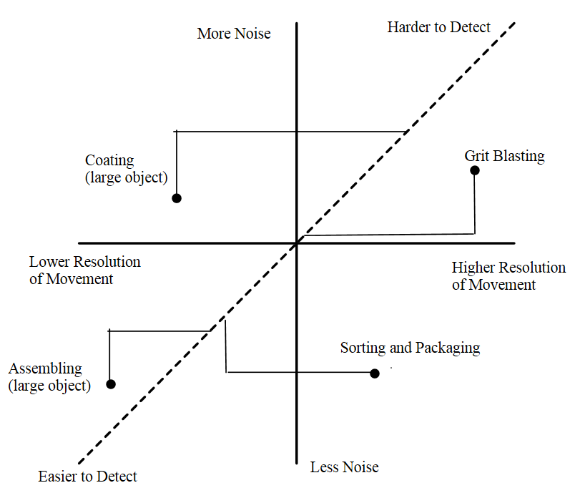

FIGURE 1

Example of Process Categorization

**Sensor Categorization**

To make knowledge capture more accurate and reliable, motion sensors, instead of the naked eye, are used to record movement of objects and people of interest. Currently, there are multiple types of motion-capturing technologies using mechanical, optical, electromagnetic, sonic, biofeedback sensing, electric field sensing, video, and inertial systems to collect data [4]. We were able to conduct data collection and analysis on four optical systems (Microsoft Kinect 1 and 2, Leap Motion, and Creative Senz3D) and one inertial system (Animazoo Motion Capture Suit IGS-180i). In addition, research was done on specifications of other sensor alternatives that the team did not have direct access to. It is of utmost importance that the system designer is aware of the latest motion sensing technologies so that high-end sensors are analyzed and considered for the more complex manufacturing processes, especially as technology constantly extends its frontier.

Each new sensor needs to be analyzed for the specific purpose of knowledge capture. The first step is assessing the intrusiveness of the sensor on the worker. Seeing as the intrusiveness of a sensor is both operator and process dependent, we provided a means to help quantify it. Both physical and psychological intrusiveness can be evaluated by interviewing the operators themselves, asking questions regarding preferences as to wearing or being observed by specific sensors or people. Another method is to convert the burden on operators to extra time or monetary values and rank options. If an option is deemed too intrusive, it can be demoted as a backup option and a list of other sensor alternatives can be considered. Similarly, if the sensor is not programmable because it does not come with a software development kit (SDK), then performing knowledge capture with that particular sensor may not be feasible.

Upon being deemed practical for use in knowledge capture, each sensor's basic functionality can be analyzed using computer programming and data analysis. Parameters that will better help characterize the sensor include: if the sensor is able to capture rotational data natively or whether it requires computation from positional data (e.g. some sensors can only compute palm rotation based on finger positions, but cannot output finger rotation data directly), if individual sensors can be relocated within the sensing system to capture more details about a specific area of the body, if the sensor is able to track objects, if the sensor is wireless, price, power source, and compatibility with other sensors.

The different ways in which these sensors function are able to satisfy the prerequisites required by different processes. Although some sensors have comparable functionalities, they exhibit different performances on these functionalities. Similar to the decomposition of manufacturing processes, sensor performance can be decomposed into three dimensions: sensitivity, noise cancellation capability, and target detection capability. Specifically put, sensitivity encompasses location accuracy, rotation accuracy, and frame rate of the sensor. Noise cancellation capability is defined by the ability of the sensor to identify and ignore physical or flying particles, acoustic sound, temperature fluctuation, and system vibration caused by various manufacturing environments. Target detection capability is defined by the sensor's dimensions of view (angle and distance), the ability to see through different media, the ability to track objects and body parts with different textures and amounts of reflections, the ability to detect all colors, and calibration frequency. Manufacturers provide user specifications for the attributes of a majority of the sensors. However, it is important for us to test the sensors in the manufacturing environment and compare observed values against the theoretical values. Values from tests can be trusted more in actual manufacturing environments.

We carried out the aforementioned tests on the five accessible sensors and categorized them according to the three dimensions mentioned above. Positional and rotational accuracies were represented by the error rates of the data collected on a preset target translation and rotation, respectively; frame rate was read off the collected data; noise was simulated by flying sand particles, aluminum residue, shaking, and loud sound; dimension of view was measured by the maximum range wherein the target could still be detected and/or visualized; various transparent and opaque materials were used to see if signals would be blocked; the ability to track glossy clothes and colors were tested with gloves with different gloss and colors; the calibration needed was referred to each sensor's manual. Each test was performed multiple times, results were bootstrapped, and 95% confidence intervals for means were constructed.

Testing results gave the functionality and performance categorizations of the five sensors shown in Table 1. Their specific categorizations were calibrated against the Kinect 1, which has "Medium" for all three performance metrics. If new sensors were added to the list and tested, another sensing technology might be the new baseline sensor. In this case, the system designer and sensor tester need to calibrate the existing results, which makes the initial baseline selection crucial to this sensor testing and categorization step.

TABLE 1

Example of Sensor Categorization

|  |  |  |  |  |  |
| --- | --- | --- | --- | --- | --- |
|  | **Functionality** | | **Performance** | | |
| **Translation** | **Rotation** | **Sensitivity** | **Noise Cancellation Capability** | **Detection Capability** |
| **Kinect 1** | Body Joints | Spine | Med | Med | Med |
| **Kinect 2** | Fingers and Body Joints | Limbs and Spine | High | High | Med |
| **Creative Senz3D** | Fingers and Palm | Palm | Low | Low | Low |
| **Leap Motion** | Fingers and Palm | Palm | High | Med | Med |
| **Animazoo IGS-180i** | Body Joints | Limbs and Spine | High | High | High |

**System Integration**

To select proper sensing technologies given a specific process, we defined three steps, as shown in Figure 2 below. First, look at the prerequisites: if sensors are deemed too intrusive by operators or not programmable, consider demoting them to the backup list. Next, utilize both process and sensor categorization to determine which sensors provide sufficient performance: sensors that are highly sensitive are ideal candidates for a process with high resolution of movements; sensors with strong noise cancellation capabilities are preferred in processes that generate lots of noise; and sensors with better detection capability are favorable if detection of subjects of interest is difficult. To find the specific category-sensor mapping, the system designer should find or compile (through testing) a list of evaluated sensors in a form similar to Table 1. Then it is important to align and calibrate the baseline of processes with the baseline of sensors. Specifically, sensors with "medium" in all three performance dimensions should be able to satisfactorily collect data in a process with "medium" in its three-way decomposition. If this is not the case, the system designer should change and recalibrate either the baseline of sensors or the baseline of processes. Lastly, s/he should match sensor functionalities with factors of interest. If palm rotations are important factors, for instance, sensors lacking this functionality can still be included but the final sensor list should contain at least one or two sensors with rotation tracking capability. If the sensors and processes are properly categorized and calibrated, then the resulting sensor list is more than likely to collect and output workable datasets for the comparison between experts and novices.

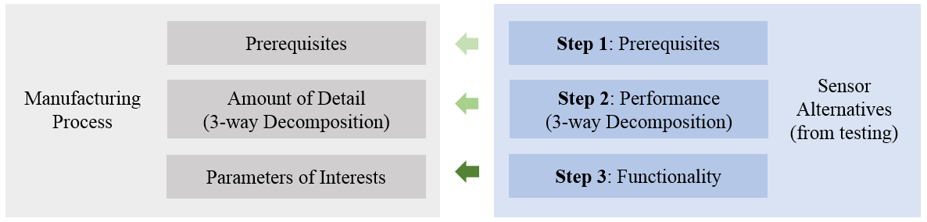

FIGURE 2

Selecting/Matching Sensors with Categorized Manufacturing Process

Before any data processing, the system designer should identify which parameters need to be analyzed such as sequence of motions, distance to a reference point/line/plane, and angle with respect to a reference direction. Simple observation on the process (e.g. finding which body parts or objects are not fixed across different sets of operations) is helpful to determine the parameters. This information is used to narrow down the collected datasets.

A general rule is that either analytical or graphical analysis should have enough dimensions to cover all parameters identified. Multiple linear regression generally supports enough predictors to capture all parameters but can only provide one response variable at a time. Using this tool is able to identify an underlying sequence of activities and correlation between parameters in manufacturing processes. For example, if there are only four parameters of interest, a simple main-effects regression model as in (1) can use an object's state (*state*), distance between the operator's hand and the object (*dist*), and the speed of movement (*speed*) to determine the angle of the operator's hand (*angle*). If more parameters (i.e. hand location) are of interest, adding new parameters to this regression, sometimes with the help of instruments and interaction terms to isolate collinearity, will meet the general rule and provide a sound fit.

$angle=β_{0}+β_{1}state+β_{2}dist+β_{3}speed+ϵ$ (1)

Likewise, when using a graphical tool to analyze the data in the previous example, it should capture all four factors, *state*, *dist*, *speed*, and *angle*. However, graphical tools can normally provide up to five dimensions through use of animation and color coding on a 3D graph. Thus, when the number of parameters is larger than five, the analyst should consider using multiple sets of graphs or giving up some parameters based on their priorities.

In order to effectively visualize the collected data, the analyst could consider applying several visualization methods, such as animated multi-dimensional plots, static multi-dimensional plots, and bubble charts. The first two demonstrate trajectories of the recorded subject (i.e. a 3D plot gives the XYZ values of right hand movements); colors of data points differentiate distinctive stages of a particular process (stage as a function of the parameters, i.e. when tilting your wrist from 0 to 20 degrees is defined as state 1 and represented by red dots). The animated plot depicts the sequence of movements, adding another dimension, time, to its static counterpart. Likewise, bubble charts are used to view multi-dimensional data simultaneously with different bubble sizes representing different frequencies. It is important to generate the same types of graphs for both experts (control group) and novices (experimental group) for comparison.

Recommendations and guidance for novices are inferred from the graphical and analytical tools either manually or automatically. These tools reproduce the different operations between novices and expert workers. This helps the former learn what and by how much s/he needs to correct in order to replicate the experts' actions during that particular process. An example of recommendations may be to tell the novice "to move hands two inches up after pressing the button" or that "it might be more efficient to assemble part B before part A."

**Illustrative Example**

With this methodology, we monitored how workers in manufacturing environments interact with their surrounding physical components and uncovered the manufacturing knowledge for product quality improvements. We explored grit blasting, where pressurized abrasive streams were used to smoothen or roughen surfaces, as a case study. Since the difference in movements between novices and experts resulted in the difference in final product quality, using sensing technologies along with data processing to identify their movements could generate recommendations for non-experts to improve operation efficiency and product quality.

Based on the process categorization, grit blasting would be considered to have high resolution of movements (due to small movements required by the operator), a high level of noise (due to particles removed from the surface of the object that were flying around in the contained working environment), and a medium detection difficulty (since the operator was grit blasting in a medium-sized and loud environment). In addition, there were three primary factors that could influence the quality of the object being blasted: standoff distance (the distance between the nozzle and the product), blasting angle (the angle of the nozzle in relation to the product), and the blasting rate (how fast the nozzle is moving in relation to the product) [5].

Next, we determined which sensors were proper for knowledge capture. In this case we limited the sensor alternatives to the five tested previously. If more options were needed, we could browse various technology websites, online blogs, and published journals to discover other state-of-the-art options. Using search keywords such as "motion" and "sensor" helped to efficiently locate relevant articles and products. After interviewing the process operators and assessing the programmability of these alternatives, we decided to keep them all for the subsequent analyses of functionality and performance.

The next step was to align the sensor baseline with the process baseline. In this case study, we checked if the baseline sensor, Kinect 1, could successfully capture quality data in the cabinet. We noticed that both its "medium" noise-cancellation capability and "medium" sensitivity slightly fell short in meeting grit blasting's "high" movement resolution and "high" noise-cancellation requirements. Meanwhile, it sufficiently projected the skeleton of the operator, meeting the "medium" detection capability requirement. This meant that the two baselines were aligned correctly and we could pick sensors directly based on their three-way decompositions. Thus, we looked up the sensor results/categorization table (Table 1) and found options with "high, high, med" or "high, high, high" on the three axes: Microsoft Kinect 2 and Animazoo IGS-180i.

Lastly, since blasting angle was a key factor, sensors with the ability to capture hand rotations were needed. Both options could either compute or capture hand rotations and they were programmable to some extent. Since we had access to both of them, we kept them on the final list.

We constructed a wooden 1:1 replica of the grit blasting cabinet and proceeded to conduct initial testing within it. For testing purposes, an authentic model was necessary since the cabinet could possibly obstruct visibility between the sensor and the operator. The inside of the cabinet was painted to replicate the color and reflective characteristics of the original one. The mock cabinet also included two light bulbs in the front, which were also seen in the actual cabinet and allowed us to factor in light interference when testing sensors. Due to the harsh environment created by blasting particles, any sensors placed within the cabinet needed to be put inside of a protective, transparent casing (Corning glass).

While all of this was good and well, this prototyping and methodology lacked significance without data collection and data processing to go along with it. Thus, we programmed using each sensor's SDK to extract data to develop a baseline for the numerical analysis of workers. Using ourselves as dummy operators, we carried out actions resembling those that occurred during grit blasting during data collection. In one trial, one of us pretended to be an expert, holding the nozzle steady with constant blasting angle, standoff distance, and speed; in another trial, she pretended to be a novice, holding the nozzle with various angles, standoff distances, and blasting speeds.

The next step was to visualize the data we obtained from the motion capture suit, and we did so through simple plotting and use of the Hidden Markov Model (HMM). Simple 3D plots put locational data on the three axes. Colors represented bucketed blasting angles, while animation and point density revealed blasting speed at different locations. The HMM, in addition, allowed us to accurately define states through computing the hidden path of movements rather than simply grouping by angle. Similar to graphing without the HMM, blasting angle states were expressed in different colors. Since both tools gave similar graphs, we show just the plots for the HMM in Figure 3, which compared the motion of the "expert" and that of the "novice".

Specifically, we grouped expert's blasting angles into four colors, either by quartiles or HMM-determined states. These four states were bounded by five parameters (e.g. in the quartile case, they are the minimum, 1st quartile, median, 3rd quartile, and the maximum). Then we imposed these five numbers on the novice data, yielding six intervals (i.e. one below the minimum, four between the quartiles, and one above the maximum) to cover all data points. The difference in the data distributions helped us check how the novice was doing in relation to the expert's performance.

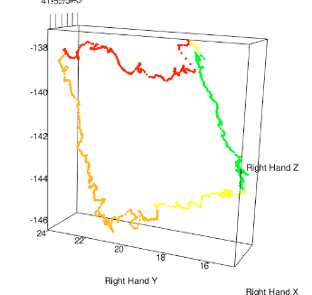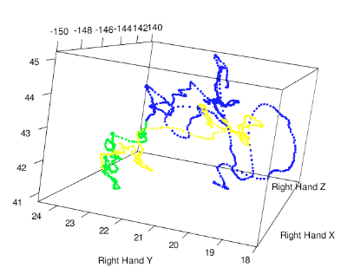



FIGURE 3

HMM 3D Plots of Expert (left) and Novice (right)

It was clear that the novice graph on the right-hand-side showed fluctuating standoff distance and an irregular sequence. In order to validate the accuracy of visualization methods, we compared the animated graphs with video recordings. Both showed the same pattern as assigned during data collection. On the other hand, Figure 3 provided valuable insights on how the novice could improve in the future. Some sample recommendations included "consider using small blasting angle and constant blasting speed" and "blast the object along straight lines". Although these recommendations are made from data obtained from mock tests, they are reflective of suggestions that could be made in a true grit blasting environment.

Aside from the two 3D graphs, we combined the states from the HMM to create a comprehensive view of the worker's actions, creating what we called the "bubble chart". This chart is simply a plot of the frequencies of the positional states, where the color of each data point represents the blasting angle. The analyst can put any combination of states on the graph. In the grit blasting case study, we chose to draw a 2D graph with x- and y-coordinates reflecting different states of the actual hand positions in left-right and forward-backward directions, respectively. In other cases, the analyst might put blasting angle states on the x-axis and standoff distance states on the y-axis, which would unveil differences in frequency between those two parameters. This plot reveals the distribution of the states of the operator throughout the process, and thus it exposes which locations of the object were used most frequently. From the comparison of bubble charts, shown in Figure 4, we could make several recommendations regarding to blasting angle and relative hand location, such as "the novice should avoid blasting in the left-bottom and middle-right area in the cabinet" or "the novice should decrease the blasting angle in the middle-left area". Just as was the case with the HMM graphs, these recommendations could be made in a true grit blasting environment.

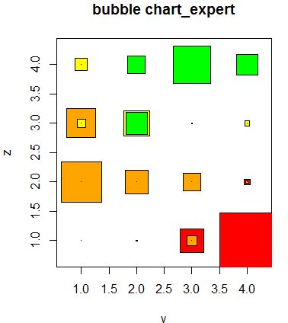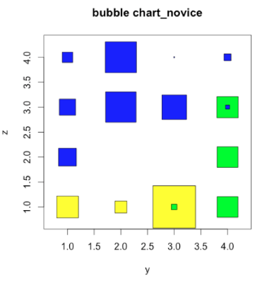



FIGURE 4

Bubble Charts of Expert (left) and Novice (right)

**Conclusion**

The grit blasting case study showed that knowledge capture can be achieved by the "categorization - system integration" methodology. This system design significantly simplifies the sensor selection process by compressing every process and sensor into a few parameters and match "demand" in functionality and performance from processes with "supply" in functionality and performance from sensors. Selecting sensors from tested technologies is as simple as locating a subsection of the testing results table. Then, through sensor setup, data collection, and data processing, the analyst is able to translate the visualizations and statistical analysis to provide recommendations to the novice worker.

In the future, we aim to create a system where users are given real time feedback (e.g. Google Glass or Oculus Rift) on their operations. This will help bridge the gap between novice and expert workers in a shorter, more effective time period. In addition, we would like to automate data processing rather than manually creating these visualizations and interpreting the findings.

**Acknowledgment**

The authors would like to acknowledge guidance and efforts from Dr. Kevin Farinholt, Dr. Matt Stremler, and Dan Moodie from Commonwealth Center for Advanced Manufacturing; Nasser Ghariban from Virginia State University; Don Rude, Ben Choo, Jama Coartney, and Carter Tata from University of Virginia, and Robert Mills from VirginiaTech. The authors take full responsibility for the ideas, concepts, opinions, and data presented here, which do not necessarily reflect those held by the aforementioned individuals.

**References**

[1] Farinholt, Kevin. Personal communication. Accessed: September 29 2013.

[2] G Mikell P. *Fundamentals of Modern Manufacturing: Materials, Processes, and Systems*. Wiley, September 2012.

[3] Fox, Nathan S., Brennan, Jennifer S., Chasen, Stephen T., *Clinical estimation of fetal weight and the Hawthorne effect*. <http://www.sciencedirect.com/science/article/pii/S030121150800300X>. Accessed: March 30, 2014

[4] Furniss, Maureen. *Motion Capture*. <http://web.mit.edu/comm-forum/papers/furniss.html>. Accessed: March 29, 2014

[5] Homa, D. and Mills, R. Surface Engineering 1: Grit Blasting Literature Review. Accessed: September 13, 2013

**Author Information**

**Wenchang Han**, Student, Department of Systems and Information Engineering, University of Virginia.

**Xiaoqian Liu**, Student, Department of Systems and Information Engineering, University of Virginia.

**Jack H. Radcliffe**, Student, Department of Systems and Information Engineering, University of Virginia.

**Maryam Ghariban**, Student, Department of Systems and Information Engineering, University of Virginia.

**Jane Wei**, Student, Department of Electrical and Computer Engineering, University of Virginia.

**Kevin C. Chung**, Student, Department of Systems and Information Engineering, University of Virginia.

**Peter A. Beling**, Professor, Department of Systems and Information Engineering, University of Virginia

**Appendix I – Detailed Sensor Analysis**

In this section, we will discuss the details about sensor categorization of the five available sensors, Microsoft Kinect 1, Microsoft Kinect 2, Leap Motion, Creative Senz3D, and Animazoo IGS-180i. The following table gives the basic characteristics, programmability, and intrusiveness. Please note that intrusiveness is composed of both physical and psychological ones and subject to change based on the actual interview of operators.

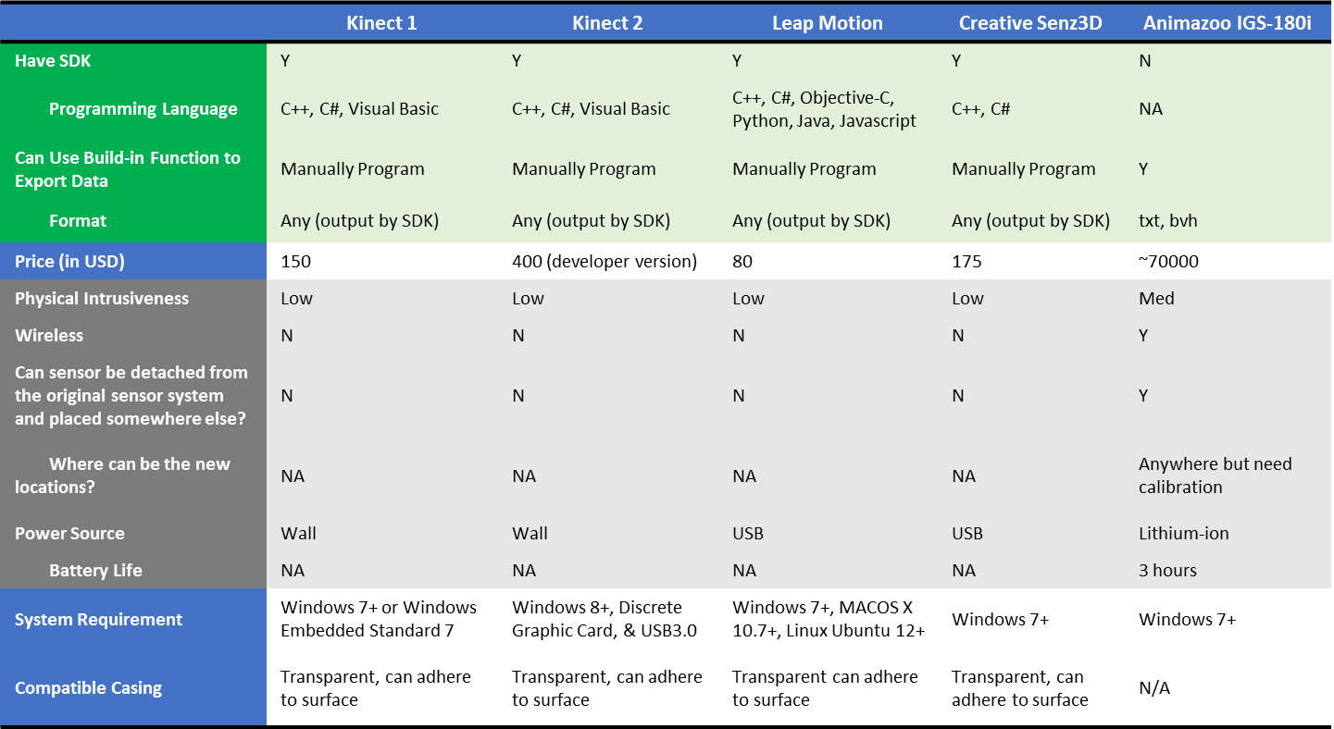

FIGURE 5

Prerequisites of Sensors

Sensor sensitivity is determined by measuring the error rate of measurements. The testing setup consists of the following steps:

1. Check the “data-stable” range of each sensor.
2. Stand or place hands on the far side of the “stable” range, start data recording for 10+ seconds, walk or move hands for a pre-determined distance, stop at the end point for 10+ seconds, and stop recording.
3. Clean the data by only using the smooth points at the starting location and the smooth points at the ending location (path independent). Only use the data in the direction of movement (for Leap Motion, “z” is used; for Senz3D, “y” is used). Use graphs to make sure that there are no obvious outliers in the “smooth” section.
4. Bootstrap the data for 2000 times and check the distance between the start and end locations. It should be close to the pre-determined distance or rotation amount. If not, consider re-collect data and assess the testing environment.
5. Calculate error rate using the ratio between actual distance difference from the collected data and the pre-determined distance.
6. Repeat this process for multiple times and take average of the error rates. This yield the final error rate for each sensor. Results are shown below.

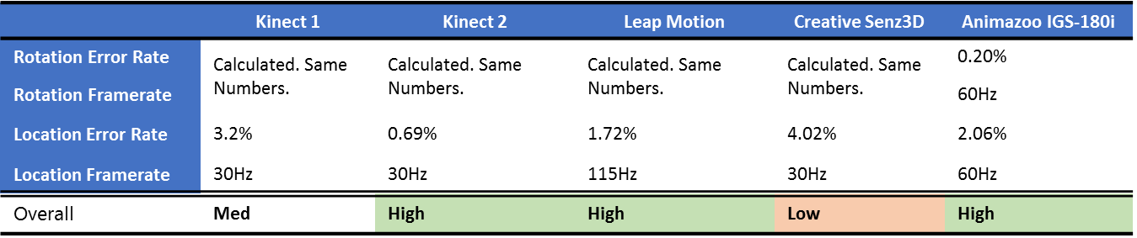

FIGURE 6

Testing of Performance - Sensitivity

Raw data and bootstrapping results are detailed in “Detailed Sensitivity Result” spreadsheet. Also note that the first four sensors use locational data to compute rotational information. Thus, rotation error rate and frame rate are dependent on the ones for location. Specifically, Leap Motion’s SDK does the conversion by itself. On the other hand, Kinect 1, Kinect 2, and Creative Senz3D are not able to output pitch-yaw-roll without manual coding. But given the location of five fingers, it is not difficult to compute the rotation of palm.

In this case, performance is calibrate against the baseline sensor Kinect 1. Although the “high” and “low” decision is not fully deterministic, when talking about error rate, 1-2% difference from the baseline should lead to the other two overall ratings.

As you can see, among the three high-rated sensors, there is a tradeoff between error rate and frame rate. To decide which one to use for a given manufacturing environment, consider assessing the frame rate requirement. If none is proposed, any one of the three is more than likely to capture quality data from the process.

Then, we look at the noise cancellation capability of each alternative. This is relatively subjective because the first four categories are hard to quantify. Basically, we are ranking the sensors with respect to each metrics and assign overall rating at the bottom. The subjectivity makes “sensor calibration” crucial during the “system integration” stage.

Additionally, temperature range, used to check the material strength and signal stability, are read off from sensor manuals. Unfortunately, Kinect 2, Leap Motion, and Creative Senz3D have no documented operating temperature. Some online materials suggest that IR sensors have similar working temperatures. Thus, although the three cells are labelled “No Info” in the following table, the working temperature range may fall under a similar range as Kinect 1’s, 5 to 35 Celsius.

However it is important to note that the sensors will be placed within a protective casing when used within the grit blasting cabinet. The purpose of the casing is to protect the sensor from damages that may occur due to temperature or flying particles that are created during the grit blasting process. The hardness (scratch rate) of the polymers including plexiglass cover used to protect sensor depends on the surface temperature. During grit blasting the high speed particles carry kinetic energy and deposit as the thermal energy to the surface.

The picture below illustrates the grit blasting process. The following sentences will describe the grit blasting process and all the components involved: The compressed air goes through a nozzle inside a blast gun. The air velocity increase and the pressure drops inside nuzzle. Grit particles are pulled through the tank by low pressure and mixed with air and leaves nozzle with high velocity. In contact with the surface of the plexiglass, the kinetic energy of the grit converts to thermal energy. Some of the thermal energy is removed by force convection due to high velocity of air. The rest of the heat increases the internal energy of the plexiglass and the temperature increases until it reaches a steady state and temperature remains constant.

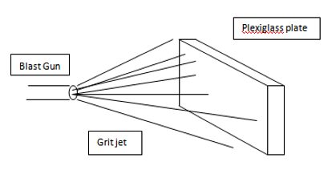

FIGURE 7

Grit Jet with Plexiglass Plate

If we assume all the kinetic energy converts to heat the rate of the heat entering to the surface will be calculated from the following equation: $\dot{Q}$ = $\frac{1}{2}\dot{m}v^{2}$

The variables in this equation include *m,* the flow rate of grit, and *v*, the velocity of the grit. The projected values for these two values can be assumed as the following: $\dot{m}$ = $1\frac{kg}{min}$ and *v*= $30m/s$

With these assumed values, the input heat energy to surface will be:

$\dot{Q}$ = $\frac{1}{2}(.0166kg/s){(30m/s)}^{2}$ =7.5 W (2)

On the other the plate dissipates heat to environment by heat convection given by the following equation:

$\dot{Q}$ = $h∙A∙∆T$ (3)

For forced heat convection with the assumed velocity it can be assumed that that h, the heat transfer coefficient, is as follows: *h*= $100\frac{W}{{}_{ }^{o}{C∙m^{2}}}$. The surface are of the sensor covered by grit blasting is represent by A. For a 5cm by 5cm surface the area will be $0.0025m^{2}$.

Finally, if the heat rate from (2) and the assumed values for h and *A* are substituted into (3) the temperature rise will be evaluated as: 7.5W= $100\frac{W}{{}_{ }^{o}{C∙m^{2}}}$ ($0.0025m^{2}$) $∆T$, which will then indicate that $∆T$ = 30 ${}_{ }^{o}C$. This indicates that the surface of the plate will be 30 degrees higher than the ambient (surrounding) temperature.

By using the equations and variables listed above, the temperature on the surface of the plexiglass was calculated. The values of each variable were kept the same as the calculations made above. The following conclusion for steady state, temperature rise ($∆T$) on the plate was found by referencing the previously calculated output value of $∆T$, which was 30 ${}_{ }^{o}C$. This lead to the finding that if the ambient temperature inside the cabinet is 25 ${}_{ }^{o}C$ then the temperature on the surface of the plexiglass will be $T_{Sur}$ =55 ${}_{ }^{o}C$. With a short amount of time, Plexiglass plate can protect different sensors from overheating. However, please notice that when heat convection and induction drive the sensor temperature up, signal quality will be jeopardized.

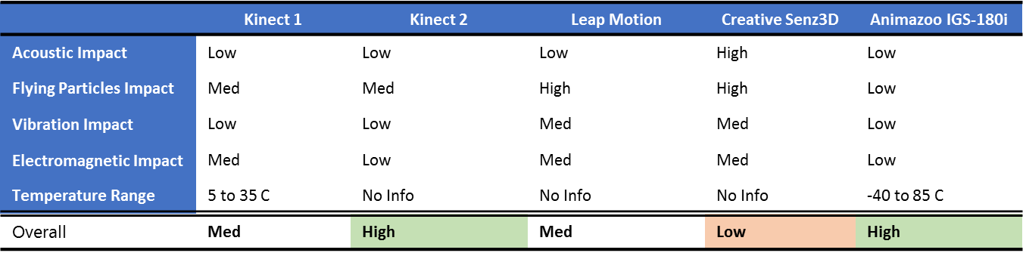

FIGURE 8

Testing of Performance - Noise Cancellation Capability

According to the general methodology, the last step of sensor categorization is to test sensors’ “detection capability.” Impact of reflected signals is the only subjective metric. It is assessed by looking at if depth data can be captured when incoming lights are bounced back from a reflective object such as a mirror.

Minimum and maximum detection distance, along with horizontal and vertical angle range are determined by moving the human subject around and check the boundary of area that the subject can no longer be detected. Angles are measured by using arctangent function. Each result is the average of multiple runs.

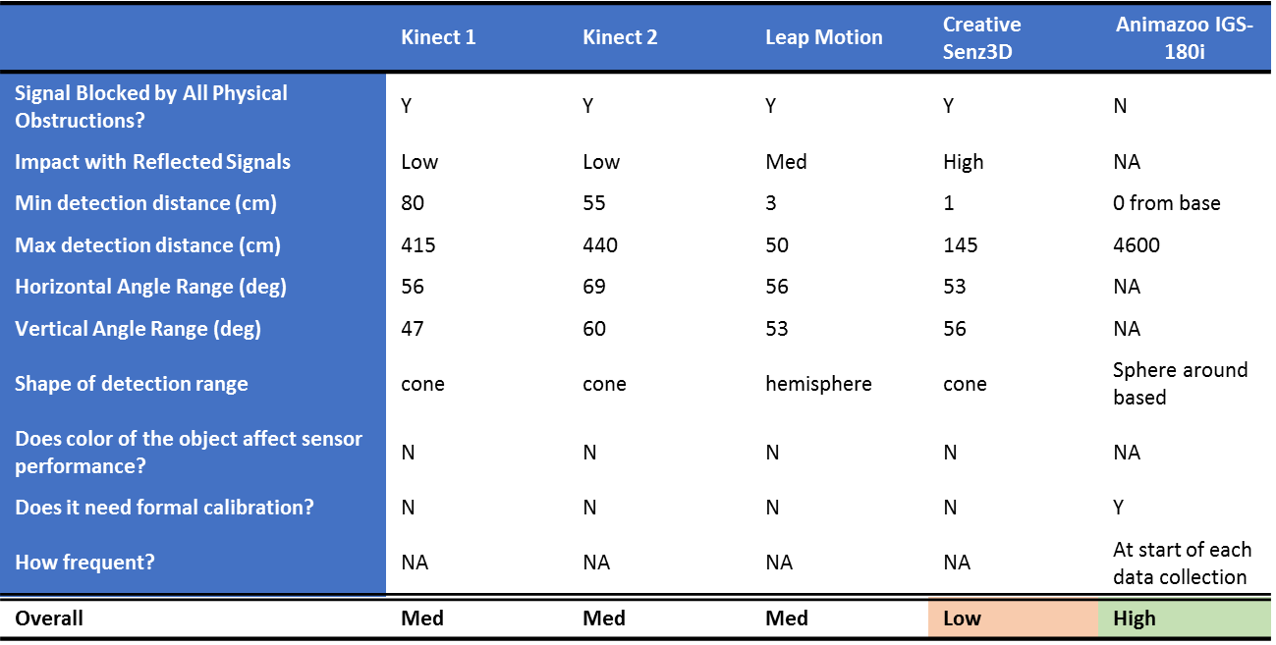

FIGURE 9

Testing of Performance - Detection Capability

Last but not least, if there are other metrics to be included, please double check if it is covered in one of the metric in the previous tables. If not, it can be added into one of the three “dimensions,” test sensors, and re-assess overall ratings of different alternatives. This is to make sure the general methodology still works without adding another dimension.

**Appendix II – Instructions on Using Source Codes**

Codes for all five sensors regarding sensor testing (especially accuracy tests), bootstrapping, HMM, and visualization (animated 3D plot and bubble chart) are detailed in the attached “core_code” file and “codes” folder. The latter includes a list of raw codes for different sensors and platforms while the former features core code sections from the raw codes.

Data Collection:

Unzip all the files in code/Data Collection folder

Kinect 1 (OS: Windows, IDE: Visual Studio)

Step 0: install Software Development Kit (SDK) (<http://www.microsoft.com/en-us/kinectforwindowsdev/start.aspx>)

Step 1: install Visual Studio

Step 2: Plug in Kinect 1, and run "SkeletonBasics WPF71 - seated.sln"

Step 3: Exit the program and when the data collection is done.

Step 4: data file is in /bin folder.

Kinect 2 (OS: Windows 8, IDE: Visual Studio)

Step 0: install Software Development Kit (SDK) that comes with Kinect 2

Step 1: install Visual Studio

Step 2: Plug in Kinect 2, and run "Kinect 2 - Visual Studio"

Step 3: Exit the program and when the data collection is done.

Step 4: data file is in /bin folder.

Leap Motion

(Java: OS: Windows, Mac, IDE: eclipse)

(C#: OS: Windos, IDE: Visual Studio)

Step 0: Register a developer account on leap motion site, and then download and install Software Development Kit (SDK) (<https://developer.leapmotion.com/downloads>)

Step 1: install Eclipse (if it's java, otherwise install Visual Studio)

Step 2: Plug in Leap Motion, and run "Leap Motion - Eclipse"

Step 3: Exit the program and when the data collection is done.

Step 4: data file is in /bin folder.

Creative Senz3D (OS: windows, IDE: Visual studio)

Step 0: download and install Software Development Kit (SDK) <https://software.intel.com/en-us/vcsource/tools/perceptual-computing-sdk>

Step 1: install Visual Studio

Step 2: Plug in creative senz3D, and run "Creative Senz3D - Visual Studio"

Step 3: Exit the program and when the data collection is done.

Step 4: data file is in /bin folder.

3D Plot:

1. Put aerojet-functions.r, animate.r, tmr.r and data files (e.g. expert2.csv and novice2_1.csv and animation1.csv) in the same folder
2. Then run "tmr.r" file
3. HMM model + 3D plot: plot3d(expert2[,1:3],col= colarray[expert2[,4]],xlab='Right Hand X', ylab='Right Hand Y', zlab='Right Hand Z');aspect3d('iso')
4. HMM moded + animation: animate1(mydata=chart,sleep=0) # sleep=0 is the fastest

Bubble Chart:

1. Download Bubble chart folder

2. Run bubble.R

Note: expert_bubble.csv shows the expected format of the data file